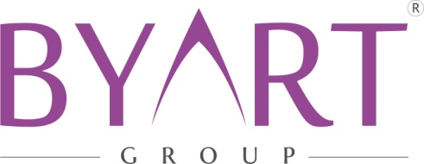

SMART ROOF MAINTENANCE SERVICE
It is an automatic roof system with aluminum panels that can be opened and closed. Working principle: It opens and closes on special aluminum alloy rails with load-bearing wheel systems and semi-automatic mechanism.
In the center of the roof panels, the double-sided COS 200 lifts off with stainless steel extension springs. The panels are connected to load-bearing wheel systems with scissors moving parallelly to each other. They open and close with a mechanism. COS 200 allows a rotational movement of the panel with stainless steel springs.It is a semi-automatic system, the panels work mechanically.The system mechanism is motorized and automated.
All systems operating with mechanisms require regular service and maintenance in order to be able to provide adequate and reliable service for many years.
We provide free maintenance (parts) service to our customers under warranty for 2 years from contract date.The warranty does not cover defects caused by user error.
It is our customers’ responsibility to request an appointment with our company to obtain service every six months.When the service is not performed every six months, customers are also requested to be careful regarding the warranty period since the products will no longer be under warranty.
We recommend you to suscribe to an annual paid service-maintenance agreement with our company for long-term and trouble-free operation of the products after two years. You can get detailed information about the maintenance contract from our company.
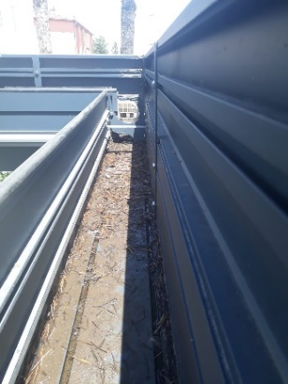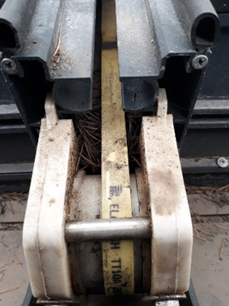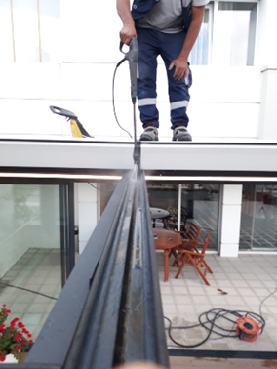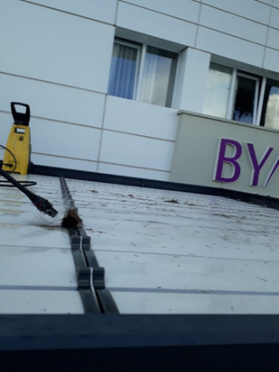

Depending on the areas of use of the systems, especially if there are plants, with flows of wood resin in the environment, the running channels of the wheels should be cleaned every 3 months.Gutters and draining channels should be opened and must be cleaned of leaves, dust and mud deposits.
If there is a road construction site near the system, these canals should be checked frequently during this time. Otherwise, the release of water will not be made in sufficient quantity in case of rapid rain fall.
At the end of the third year, controls of the moving mechanisms, the change of the worn or damaged parts is very important so that the system serves as the first day and for many years.
-The resistance of the CO 200 stainless steel extension springs must be checked.
- Worn or damaged parts on the wheels are replaced.
-The scissors are checked and their shape is modified and renewed.
-Polyamide panel heads are checked, parts formed by microfissures or fractures are renewed.
- The mobility of wheels, bearings and tensioning devices is increased with special fluid materials that do not retain dust.
